**Last Update: 3/20/19**

RS5 Validation Guide

**Summary:** This document provides implementation steps to implement and test the Precision Time Protocol client on Windows 10 and Server 2019.

This guide should be accompanied by the Software Timestamping and Time Accuracy Validation guides found here: <https://github.com/Microsoft/W32Time>

Table of Contents

Overview 3

Description 3

Troubleshooting and Feedback 4

Test Activities 4

Activities 4

Activity 1: Configure the System for High Accuracy 4

Activity 2: Configure the PTP Client 4

Activity 2: Configure the Firewall 4

Activity 3: Verify PTP Provider Configuration 5

Troubleshooting 6

PTPd Grandmaster 7

LinuxPTP (ptp4l) Grandmaster 7

Example Configurations with PTPd 7

# Overview

Many sectors require accurate time. The financial sector requires accurate time so that transactions are properly timestamped to 50ms, 1ms or even 100µs accuracy. Windows Server 2019 and the corresponding Windows 10 release continues to improve Windows’ accuracy by leveraging a new time synchronization client protocol, Precision Time Protocol.

# Description

Think back to the last thunderstorm you saw  – Did you see lightning and hear thunder at the same time?  Unless you’re very close to the storm, you’ll likely detect an audible delay after you’ve seen the lightning.  How much of an audible delay are you experiencing?  The delay is not based strictly on the speed of sound and your distance from the storm.  It's also affected by buildings or other influences that introduce additional acoustic delay.  If you want to know just how close to the storm you are, you'd have to consider all the influences.

[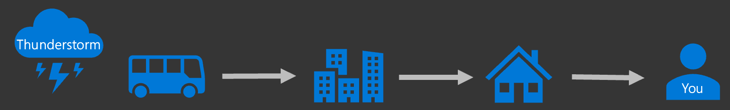](https://msdnshared.blob.core.windows.net/media/2018/06/tstorm.png)

Likewise, there is delay (latency) introduced in the timing packets being passed from the time server across the network.  If that delay is not accounted for, or if it is not symmetric (equal in both directions – to and from the client), then it becomes increasingly difficult for the client to properly apply the time stamp sent from the time server.

[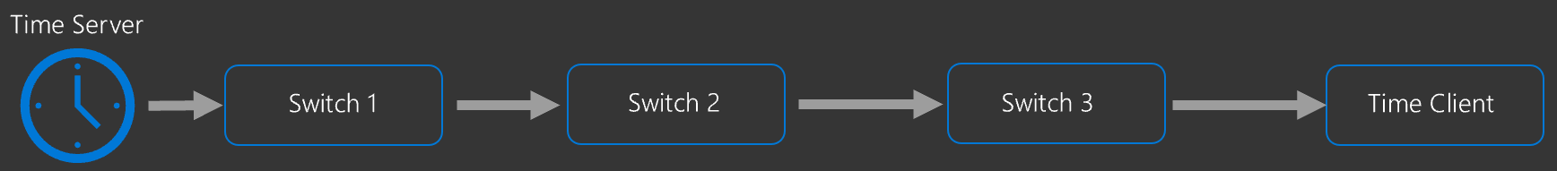](https://msdnshared.blob.core.windows.net/media/2018/06/TIme2Client.png)

Network Time Protocol (NTP) has long been the primary time synchronization method for Windows but unfortunately, NTP does not have a solution to this problem; NTP assumes that the round-trip delay introduced by the network is symmetric.

Precision Time Protocol ([IEEE 1588v2](https://standards.ieee.org/findstds/standard/1588-2008.html)) enables network devices to add the latency introduced by each network device into the timing measurements thereby providing a far more accurate time sample to the endpoint (Windows Server 2019 or Windows 10, host or virtual machine).

Precision Time Protocol is not for everyone; due to the network configuration requirements, NTP will continue to be supported (and default) protocol.  However, for customers with the highest of accuracy requirements, you can drive towards even higher accuracy systems using our inbox PTP Client in Windows Server 2019.

Operating System Requirements

Software timestamping is currently supported only on Windows Server 2019 and Windows 10 (v1809). This feature is available on current Insider builds.

# Troubleshooting and Feedback

Please submit an issue at: <https://github.com/Microsoft/SDN/issues> and add the [Time](https://github.com/microsoft/sdn/issues?q=is%3Aissue+is%3Aopen+label%3Atime) tag

# Test Activities

Below are the activities included to validate this feature:

1. Configure the PTP Client Provider
2. Activity 2

# Activities

## Activity 1: Configure the System for High Accuracy

PTP is intended for the highest accuracy time. As such you should also configure your system for high accuracy prior to proceeding. The high accuracy settings and configuration can be found here: [Link](https://docs.microsoft.com/en-us/windows-server/networking/windows-time-service/configuring-systems-for-high-accuracy?tabs=MinPollInterval)

## Activity 2: Configure the PTP Client

This activity will help you configure the Windows PTP Client to communicate with your third-party PTP Time server.

First, configure the following registry keys. We’ll disable the other client providers to avoid confusion.

**Note**: Modify the following entry "10.10.10.10 10.10.10.11" as a space-separated list of your PTP grandmasters

**Note**: To use Multicast (off by default) change the EnableMulticastRx to 1

|  |  |  |
| --- | --- | --- |
| **Root Key** | HKLM\SYSTEM\CurrentControlSet\Services\W32Time\TimeProviders\PtpClient | |
| **Type** | **Name** | **Value** |
| REG_SZ | PtpMasters | "10.10.10.10 10.10.10.11" |
| REG_DWORD | Enabled | 1 |
| REG_DWORD | InputProvider | 1 |
| REG_SZ | DllName | "c:\windows\system32\ptpprov.dll" |
| REG_DWORD | DelayPollInterval | 0x3e80 |
| REG_DWORD | AnnounceInterval | 0x0fa0 |
| REG_DWORD | EnableMulticastRx | 0 |
| **Root Key** | HKLM\SYSTEM\CurrentControlSet\Services\W32Time\TimeProviders\NtpClient | |
| REG_DWORD | Enabled | 0 |
| **Root Key** | HKLM\SYSTEM\CurrentControlSet\Services\W32Time\TimeProviders\VMICTimeProvider | |
| REG_DWORD | Enabled | 0 |

Next, restart the Windows Time Service

**Note:** See <https://github.com/Microsoft/SDN/tree/master/Time/PTP> for some simple automation help of these settings.

## Activity 2: Configure the Firewall

Create the following Firewall rules to allow the PTP Client to communicate with the time server.

|  |  |  |  |
| --- | --- | --- | --- |
| **Name** | **Direction** | **Protocol** | **LocalPort** |
| PTP Event In | In | UDP | 319 |
| PTP Event Out | Out | UDP | 319 |
| PTP General In | In | UDP | 320 |
| PTP General Out | Out | UDP | 320 |

**Note:** See <https://github.com/Microsoft/SDN/tree/master/Time/PTP> for some simple automation help of these settings.

## Activity 3: Verify PTP Provider Configuration

1. Verify that the PTP Time Provider is loaded and enabled by running the command **w32tm /query /configuration**

Each loaded provider will have an entry under the **[TimeProviders]** section. The **Enabled** property will be 1 if it is enabled.

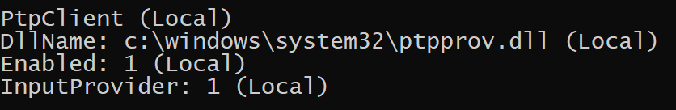

1. Now attempt a resynchronization using the **w32tm /resync**
2. Now verify that the system is synchronizing with the PTP Source Server

**w32tm /query /status /verbose**

*Leap Indicator: 0(no warning)*

***Stratum: 3*** *(secondary reference - syncd by (S)NTP)*

*Precision: -23 (119.209ns per tick)*

*Root Delay: 0.0006638s*

*Root Dispersion: 0.0100020s*

*ReferenceId:* ***0x4D505450 (source IP:  77.80.84.80)*** *– This indicates PTP*

*Last Successful Sync Time: 5/1/2018 7:10:46 PM*

***Source: 10.11.12.1    – This indicates your specific PTP Server***

*Poll Interval: 6 (64s)*

*Phase Offset: 0.0368311s*

*ClockRate: 0.0156250s*

*State Machine: 1 (Hold)*

*Time Source Flags: 0 (None)*

*Server Role: 0 (None)*

***Last Sync Error: 0 (The command completed successfully.)    – This indicates your last sync was successful***

*Time since Last Good Sync Time: 2.8389207s*

In the output above, the Reference ID ***0x4D505450 (source IP:  77.80.84.80)*** indicates that the PTP Provider is in use. If you don’t see this, then a non-disabled PTP provider you may not have disabled the other providers.

Note: Why 0x4D505450? This is the ASCII Conversion for “MPTP” (Microsoft PTP)

# Troubleshooting

Please note: As Microsoft provides a PTP Client, troubleshooting various grandmaster implementations is out-of-scope for support.

Mention of any specific grandmaster should not be considered advertisement, recommendation, or any other type of endorsement of said grandmaster. Specifics here are only included to assist in troubleshooting.

If you’re system is unable to receive time from the grandmaster, please verify:

1. You are receiving PTP Messages on the Windows client for UDP ports 319 and 320
2. The Grandmaster properly advertises the PTP_TIMESCALE and PTP_UTC_REASONABLE flags

For security measures, the Windows PTP Client will only synchronize with a grandmaster if its PTP_TIMESCALE and PTP_UTC_REASONABLE flags are non-zero.

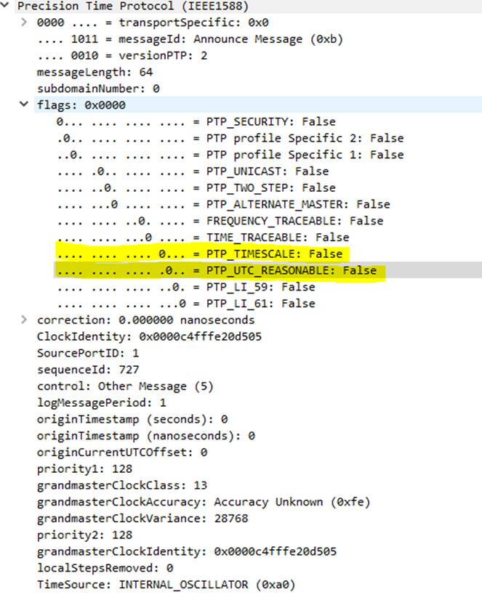

## PTPd Grandmaster

Microsoft validated this configuration with multiple grandmasters including [PTPd](https://github.com/ptpd/ptpd/commits/master).

Specific version used for testing:

<https://github.com/ptpd/ptpd/tree/235e9b492863b6a7d394a0c62d5f8e3d4d19930f>

Compiler: Gcc/xenial package version: 4:5.3.1-1ubuntu1 (“devel” selection, amd64)

install gcc using “sudo opt-get gcc”

Instructions for running ptpd (mileage may vary. Refer to ptpd documents for clarifications):

* Copy the ptpd source tree onto a linux machine
* Make sure gcc and associated packages are installed
* Run make in the ptpd source root. This should generate the binary “**ptpd2**” in the **src** folder.
* You need the **ptpd2** binary and a custom configuration file (shared here with the .conf suffix) in order to run ptpd.
* To run the ptpd service, “**sudo ptpd2 -c <your custom conf file>**”
* Verify that ptpd is running using the command “**ps -aux |grep ptpd”** and look for a process with the command line you used in the previous step. Note the process id in the 2nd column for the next step.
* In case you want to stop ptpd (may be you want an updated conf file to be used), **kill -9 <PID from the prev step>**(There may be a better way to do this, but this works).
* Verify that the Linux Firewall is not preventing traffic from communicating with the Windows client.

Verifying ptpd2 is working:

1. Run wireshark on a windows machine that is connected to the same network and examine ptp traffic
2. Ptpd logs (ls /run/ptp*)

## LinuxPTP (ptp4l) Grandmaster

According to various documentation sources ([including here](http://rpm.pbone.net/index.php3/stat/45/idpl/24646060/numer/5/nazwa/ptp4l.conf))

“In software and legacy time stamping modes it announces Arbitrary timescale mode, which is effectively UTC here, in hardware time stamping mode it announces use of PTP time scale.”

As previously noted, the Windows PTP Client requires the PTP_TIMESCALE flag to be non-zero.

## Example Configurations with PTPd

Please refer to [this Microsoft SDN GitHub location](https://github.com/Microsoft/SDN/upload/master/Time/PTP) for example configurations with PTPd.